OPTIMIZATION OF THE LOGISTICS NETWORK OF THE SELECTED ONLINE STORE
Mykhailo Dobroselskyi, Radovan Madleňák²
Abstract: The Internet serves as the main infrastructure for global shopping. E-shops offer clients various goods and services and after buying, they try to quickly distribute them to their customers. For this purpose, the construction of an e-commerce logistics network is the main aspect of successful existence in the virtual environment.
This paper analyses the logistics system of the company located in Ukraine. The core business of the company is selling the diagnostic equipment for cars through the online store. The structure of the company consists of one warehouse and five branches. The company does not have its own fleet for transportation of products from warehouse to branches or to end customers and it outsources the services of another logistics company.
The main goal of the paper is to optimize the existing logistics system of the product flow between the warehouse, branches and the final buyers of the online store.
At the end of the paper, there is a comparison of the existing and the optimized logistics network in terms of speed and cost of transportation between the warehouse, branches and the final buyers.
JEL Classification Numbers: L81, L87, L91
Keywords: online shopping, e-commerce, inventory management, logistics, truck logistics, logistic network design

Introduction
The rapid growth of the Internet and its penetration into the most diverse spheres of social life is one of the main trends not only in the modern world of electronic commerce, but also in the modern world in general. The rapid development of information technology in the past ten years has fundamentally changed the approach to the business. The emergence of global networks, such as the Internet, has led to a new approach to the organization of commercial activities. The transformations affected both the external forms of business and the internal structure of the companies themselves (Nikolayeva et al, 2013; Bachanova et al, 2009).
The Internet has become both a medium of communication and a market with tens of millions of potential buyers with a fairly high level of income (TNS Interactive, 2002; Drozdziel et al, 2017). In these conditions, commercial organizations with special structure and other management principles are formed. Not surprisingly, electronic communications began to be used in the conclusion of various transactions.
Another mixture involving e-shopping and in-store shopping is to search for a product online, check it out in-store, and finally buy it online. Thus, e-shopping lift the time and space constraints of the shopping process and bring more flexibility, leading ultimately to a fragmentation of the shopping activity in time and space (Farag, et al 2007, Couclelis, 2004; Madlenak, 2015).
Business does not stand still, companies compete with each other, looking for new ways to attract customers and sell their products. In a single information space, a trade organization can interact directly with any potential client, no matter where in the world he is located, and receive almost instant information about his decision (Nikolaeva et al, 2013; Ward et al, 2002).
Analysis of the current situation
Today, logistics usually means the process of organization movement of material and information flows to ensure the achievement of the objectives of the enterprise (Tolmachyov, 2013; Stalmasekova et al, 2017).
The main goal of logistics is to deliver production products to the right place at the right time and place with the minimum cost. There are two ways to organize business processes for delivering goods to customers (Tolmachyov, 2013; Andreev, 2012; Madlenak et al, 2016):
- formation and maintenance of its own delivery service;
- transfer of business process to courier service;
The traditional approach to the organization of delivery is the creation of its service. The undoubted advantage of this approach is the speed of delivery. The main difficulty of this approach to logistics is the need to spend considerable amount of time and money on setting up the process of courier delivery. The content of this delivery is not always cost-effective, since the following additional costs arise (Andreev, 2012; Mikhailuk, 2016):
- manager's time required to instruct the new qualified employee responsible for the delivery and debugging of the delivery business process;
- maintenance of qualified personnel, preparation of supporting documentation for orders, daily calculation of optimal routes, monitoring the smooth operation of the service;
- financial costs of maintenance (overhead costs, wages, taxes);
- simple couriers and transportation are possible in case of uneven receipt of orders or their absence.
The transfer of the business process of delivery to professional courier services allows online stores to reduce risks and devote more time to the development of sales than logistics. In addition to actual delivery to the final consumer, such companies provide a fairly wide range of services: responsible warehousing of your goods, export of goods from an online store warehouse, cash services, the ability to select narrower delivery intervals, delivery after 19.00, the possibility of issuing goods at issuing points, call centres, tracking goods to the end, etc (Andreev, 2012; Madlenakova et al, 2016).
The objective and methodology
The main goal of the paper is to optimize the existing logistics system for the transportation of goods between a warehouse, branches and end-users of an online store. The result of this paper is to reduce the transportation costs.
To achieve the goal, we have analysed the current system of delivery of goods from warehouse to affiliates and calculated the amount of shipping costs at the current turnover of the goods. With the help of the Tabu Search algorithm (Erdoğan, 2017a), we have identified a new optimal warehouse location and realised calculations of transportation costs when we changed the location of the warehouse. By using the Large Neighbourhood Search algorithm (Erdoğan, 2017b), we designed present routing system (outsourced by courier service) between warehouse and branches and proposed future routing system (with own car fleet). On the basis of calculated transportation costs, we could formulate the final decision about optimal routing system of the company.
The results
- Present state of logistics network
The existing logistic network of the company consists of one warehouse (in Kharkov) and five branches (in Odessa, Lvov, Dnipro and two in Kiev). The company does not have its own fleet to transport products from stock to subsidiaries or end users. The store, in addition to the sale of equipment for diagnostics of cars, has a wide range of spare parts and tools for their repair of cars. The exchange of products between the warehouse, the affiliates and the end user is carried out by the outsourcing logistics company. The organisation of warehouses and branches you can see at the Figure 1. The average quantity of goods transported from the main warehouse to a one branch is 1 palette of 1200 x 800 x 2000 mm every third day of the current month (an average of 9 times per month). The price list of the company that provides transportation services is depicted in Table 1. Given the amount of transportation costs and knowing their interval, you can easily calculate the cost of transport services per month (Table 1).
Figure 1: The organisation of the main warehouse and branches (0 - main warehouse in Kharkiv, 1 - Dnipro, 2 - Odessa, 3, 4 - Kiev, 5 - Lvov).
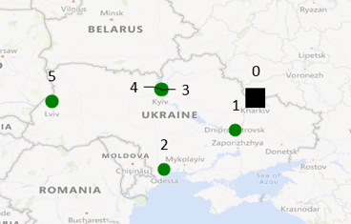
Source: Author

Table 1. Price list of transportation services.
City | Price for 1 pallet (EUR) | Price per month (1 pallet 9 times per month to 5 affiliate = 45 pallets) (EUR)
Kharkov, UA | Main warehouse | Main warehouse
Dnipro, UA | 30 | 270
Odessa, UA | 35 | 315
Kiev1, UA | 35 | 315
Kiev2, UA | 35 | 315
Lvov, UA | 47 | 420
Total EUR | 182 | 1635

Source: Author
- Change location of the warehouse – optimised logistic network
From our point of view, the location of the main warehouse is strategically unprofitable, as the distance between it and the branches is quite large and takes longer and more delivery costs. Therefore, we considered to find the new position of warehouse. For that reason, we used Tabu Search algorithm (Figure 2). According the optimisation process, the new place for warehouse became in Kiev.
Figure 2. Optimal location of the warehouse (5 - warehouse; 4 - Kyiv; 1 - Kharkiv; 2 - Dnipro; 3 - Odessa; 6 - Lviv).
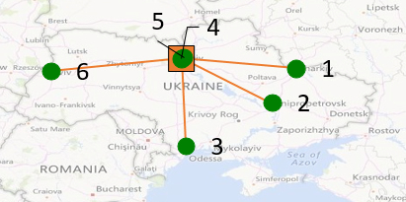
Source: Author
After finding a new location of the warehouse, we can calculate how the cost of transportation services will change. But the conditions are the same (the same logistic company and same turnover of the products) as it was in previous version of system (Table 2).
Table 2. Prices list for transportation services.
City | Price for 1 pallet (EUR) | Price per month (Kharkov) (EUR) | Price per month (Kiev) (EUR)
Kharkov, UA | 35 | 315 | 0
Dnipro, UA | 35 | 315 | 270
Odessa, UA | 35 | 315 | 315
Kiev 1, UA | warehouse | warehouse | 315
Kiev 2, UA | 0 | 0 | 315
Lvov, UA | 35 | 315 | 420
Total EUR | 140 | 1260 | 1635

Source: Author
When we compare the prices for transportation in present and optimised version of logistic network, we can find, that the price for delivery services decreased by 23%.
- The change of the way goods are transported
Another form how to improve existing logistic network is to change the way how the goods between the warehouse and branches are transported. We considered the version of the logistic network, where online store provides the transportation with own vehicle. We calculated and analysed at which turnover of goods per month own transportation will be advantageous for the online store. To do this, we chose two of those cars. The first type can carry up to 10 pallets at a time - the Mitsubishi Canter, the fuel consumption of this car costs 0.135 cents / km. The second type of car is designed to carry up to 30 pallets - SCANIA P-340, the fuel consumption of this car will be 0.233 cents / km. By using Large Neighbourhood Search algorithm, we find the delivery route of goods between warehouse and affiliates (Figure 3). This route takes 2510 km (The distance of the route is the same for present (warehouse in Kharkov) and optimised (warehouse in Kiev) version of logistic network - Figure 3).
Figure 3. Delivery routes for transportation with own vehicle.
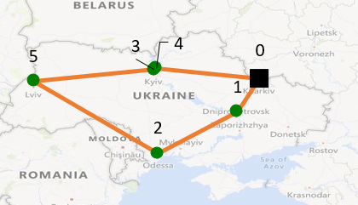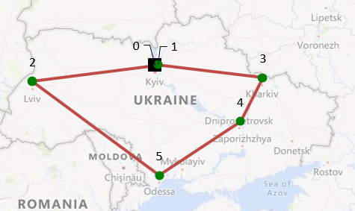
Source: Author
When we found an optimal delivery route (solution with own car), we can calculate the cost of transportation for this version. In the Table 3 we are comparing the operation costs of present construction of logistic network (Kharkov) with the operation costs of optimised construction of logistic network (Kiev).

Table 3. Price list of transportation services.
City | 5 pallets for 1 time | 5 pallets for 1 time | Own car up to 10 pallets | Own car from 10 to 30 pallets
 | Main warehouse in Kharkov | Main warehouse in Kiev | Road 2510 km | Road 2510 km
Kharkov, UA | 0 | 315 | 337 | 583
Dnipro, UA | 270 | 315
Odessa, UA | 315 | 315
Kiev1, UA | 315 | 0
Kiev2, UA | 315 | 0
Lvov, UA | 420 | 315
Total EUR per month | 1635 | 1260 | 3035 | 5250

Source: Author
According the date form the Table 3 we can calculate and compare the total cost of delivery depending on the number of pallets (Table 4).
Table 4. Comparison of costs depending on the number of pallets.
Number of pallets/month | Cost (EUR) of services for the month (warehouse in Kharkov) | Cost (EUR) of services for the month (warehouse in Kiev) | Cost (EUR) of services for the month (own car)
45 | 1635 | 1260 | 3035
90 | 3270 | 2520 | 3035
135 | 4905 | 3780 | 5250
180 | 6540 | 5040 | 5250
225 | 8175 | 6300 | 5250
270 | 9810 | 7560 | 5250

Source: Author
According the data from the Table 4, we can find, when the number of transported pallets exceeds 85 pieces per month (warehouse is located to Kharkov), the transportation costs of the outsourcing logistic service are equal to the transportation costs of own vehicle use. If the warehouse will move to Kiev, the transportation cost of the outsourcing logistic service will be equal to the transportation cost of the own vehicle use exactly when the number of transported pallets will be more than 185 per month (Picture 1).
Picture 1. Comparison of costs, depending on the number of transported pallets, location of warehouse and transportation mode
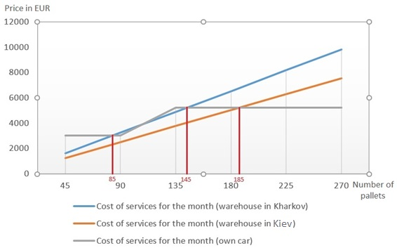
Source: Author
CONCLUSIONS
After analysing the existing logistic network system, we arrived at the following conclusions:
In order to optimize the existing logistics network system, it is possible to change the localisation of the warehouse from Kharkov to Kiev. This will reduce the cost for transportation services provided by outsourced logistic company by 23%.
When the number of transported pallets exceeds 85 pieces per month, the transportation costs by the outsourced logistic company is approximately equal to the transportation costs when we use the own vehicle. If the number of transported pallets will be higher than 145 per month, it will be better to use own vehicle for transportation.
In the case, when the warehouse will be moved to Kiev and the number of transported pallets will be higher than 185 per month, it will be more profitable for the online store to use own vehicle for transportation.
It highly depends on the final decision of company management what they will do in the future. We recommend them:
- In the first phase to move the warehouse from Kharkov to Kiev, it will bring them the benefits instantly by reduction of transportation cost.
- In second phase, they could think about the providing the transportation by own way. They could purchase of the own vehicle (truck) for transportation of goods from warehouse to the regional branches. This decision is depending on the future demand for the products of the online store. If the company will expect the increasing demand for the products, then they can buy own vehicle and this way of transportation goods will be profitable.
In the future research, we are planning to carry out more detailed economic calculations of the own vehicle transportation costs, including all aspects of operational cost (for example: servicing the vehicle, amortization, driver's salary, etc.). Also, we will focus on calculating the optimal delivery time that will consider the open hours of branches and the driving time of the vehicle.
Acknowledgements
This paper was developed under the support of project: VEGA 1/0721/18 the research of economic impacts of visual smog on transport using methods of neuroscience.
References
Andreyev, A. (2012). Prodayem virtual'no, dostavlyayem real'no! Logistika Internet-magazinov [We sell virtually, we deliver really! Logistics online stores.]. Logistika, (11), 14-15. from https://elibrary.ru/item.asp?id=18244848
Bachanova, P., Corejova, T., & Rostasova, M. (2009). The green issues of postal industry in Europe. Cers 2009 - 3rd Central European Conference in Regional Science, International Conference Proceedings - Young Scientists Articles, 901-905.
Couclelis, H. (2004). Pizza over the Internet: E-commerce, the fragmentation of activity and the tyranny of the region. Entrepreneurship & Regional Development 16, 41–54.
Drozdziel, P., Winska, M., Madlenak, R., & Szumski, P. (2017). Optimization of the position of the local distribution centre of the regional post logistics network. Transport Problems, 12(3), 43-50. doi:10.20858/tp.2017.12.3.4
Erdoğan G. (2017a); FLP Spreadsheet Solver, Retrieved from http://people.bath.ac.uk/ge277/index.php/flp-spreadsheet-solver/
Erdoğan G. (2017b); VRP Spreadsheet Solver, Retrieved from http://people.bath.ac.uk/ge277/index.php/vrp-spreadsheet-solver/
Farag, S., Schwanen, T., Dijst, M., & Faber, J. (2007). Shopping online and/or in-store? A structural equation model of the relationships between e-shopping and in-store shopping. Transportation Research Part A: Policy and Practice, 41(2), 125-141.
Ward, M.R., Morganosky, M. (2002); Consumer acquisition of product information and subsequent purchase channel decisions M.R. Baye (Ed.), Advances in Applied Microeconomics: The Economics of the Internet and E-Commerce, Elsevier Science, Amsterdam
Madlenak, R., Madlenakova, L., & Stefunko, J. (2015). The variant approach to the optimization of the postal transportation network in the conditions of the Slovak republic. Transport and Telecommunication Journal, 16(3), 237-245. doi:10.1515/ttj-2015-0022
Madlenak, R., Madlenakova, L., Stefunko, J., & Keil, R. (2016). Multiple approaches of solving allocation problems on postal transportation network in conditions of large countries. Transport and Telecommunication Journal, 17(3), 222-230. doi:10.1515/ttj-2016-0020
Madlenakova, L., Matuskova, M., & Hrudkay, K. (2016). Intermodal Transport Terminals as Part of the Postal Transportation Network. 20th International Scientific Conference on Transport Means 2016, Juodkrante, LITHUANIA.
Mikhaylyuk, M. V. (2016). Tsepi postavok i internet-logistika v usloviyakh mnogokanal'nogo razvitiya riteyla.[Supply chains and Internet logistics in the conditions of multichannel retail development] Simvol nauki, (12-1) from https://cyberleninka.ru/article/n/tsepi-postavok-i-internet-logistika-v-usloviyah-mnogokanalnogo-razvitiya-riteyla
Nikolayeva, I. P., Lezhnev, YU. V. (2013). Problemy razvitiya elektronnoy torgovli. [Problems of development of electronic commerce] Izvestiya Volgogradskogo gosudarstvennogo tekhnicheskogo universiteta, (11), 62-74. from https://elibrary.ru/item.asp?id=19419355
Stalmasekova, N., Genzorova, T., Corejova, T., & Gasperova, L. (2017). The impact of using the digital environment in transport. 12th International Scientific Conference of Young Scientists on Sustainable, Modern and Safe Transport, 192, 231-236. doi:10.1016/j.proeng.2017.06.040
TNS Interactive (2002); Global e-Commerce Report 2002. http://www.tnsofres.com/ger2002/ (accessed 5.7.2004);
Tolmachev O. V. (2013). Logistika tovarodvizheniya [Logistics of distribution of goods] : uchebnoye elektronnoye tekstovoye izdaniye / O. V. Tolmachev ; nauchnyy redaktor N. M. Tret'yakova ; Ural'skiy federal'nyy universitet imeni pervogo Prezidenta Rossii B. N. Yel'tsina, Institut «Vysshaya shkola ekonomiki i menedzhmenta», Departament NOTS «INZHEK», Kafedra ekonomiki prirodopol'zovaniya. — Yekaterinburg, 2013. — 360 s. — from http://hdl.handle.net/10995/28157.

Mykhailo Dobroselskyi, Deparmentof Communications, The Faculty of Operation and Economicsof Transport and Communications, University of Žilina, Slovak Republic, mykhailo.dobroselskyi@fpedas.uniza.sk 2 Radovan Madleňák, Deparmentof Communications, The Faculty of Operation and Economicsof Transport and Communications, University of Žilina, Slovak Republic, radovan.madlenak@fpedas.uniza.sk

